**Compass bearing**

## **Step 1: Make it**

### **What is it?**

Turn your micro:bit into a simple compass which shows its bearing from magnetic North in degrees.

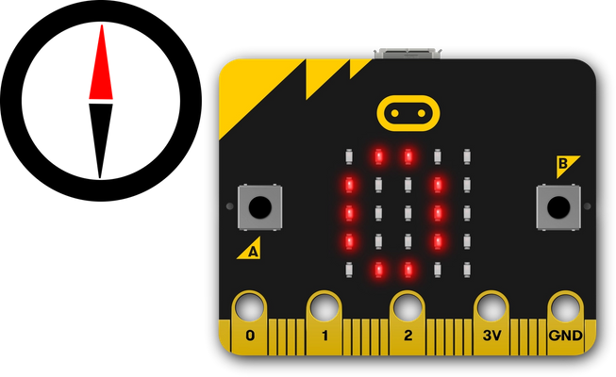

### **How it works**

* Your micro:bit has a built-in compass sensor called a magnetometer. You can use it to measure the Earth’s magnetic field and use it as a compass.
* When you first use the micro:bit compass you have to calibrate it – a little game appears on the screen where you have to tilt the micro:bit to light up every LED, then you’re ready to go.
* When you press the button A input, the micro:bit takes a reading from the compass sensor and shows the device’s numerical compass bearing on the LED display output. Point the micro:bit North and you should see a reading of 0 degrees.

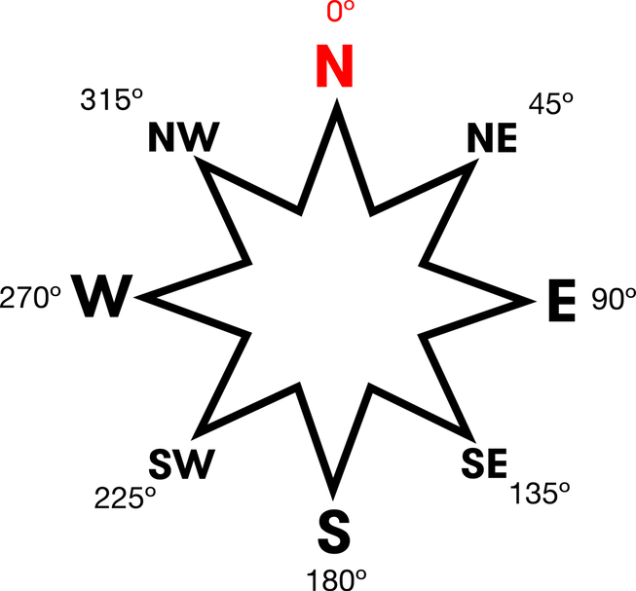

### **What you need**

* micro:bit (or MakeCode simulator)
* MakeCode or Python editor
* battery pack (optional)
* a planet with magnetic poles to stand on – for example, Earth!

## **Step 2: Code it**

## **Step 3: Improve it**

* Add another button to recalibrate the compass.
* Have the micro:bit make a sound when it’s pointing in a particular direction – this could be useful to help navigation when you can’t look at a display or for people with impaired vision.
* Make the micro:bit display letters or arrows to show if it’s pointing North, South, East or West.